For my final project I chose to utilize Google’s teachable machine to solve a fairly simple problem. When shown an image, what time is it? Is it day or is it night? Despite being a trivial question for humans, I was interested in how simple it would be for an algorithm to do something similar.

The implementation process of this problem was also fairly simple. I was able to google images of either a sunny morning or a starry night and feed it into the teachable machine.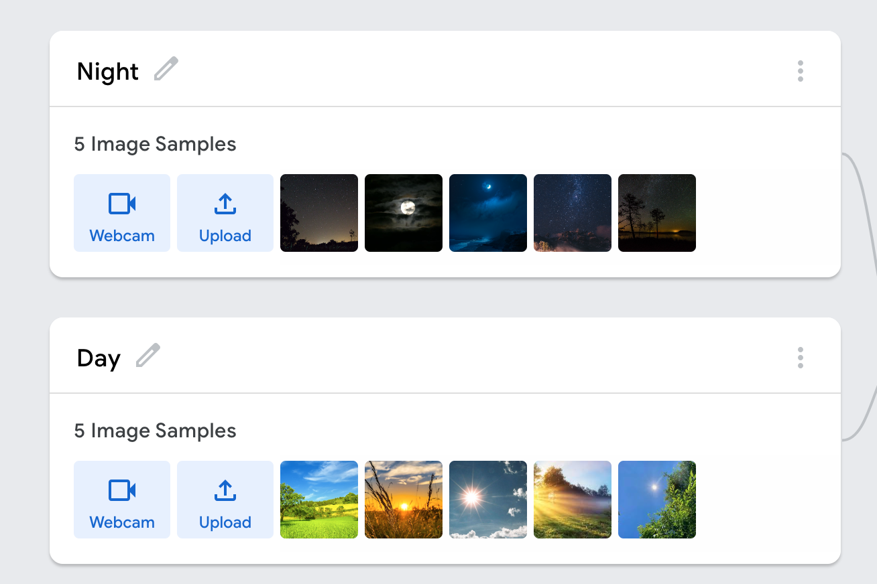

I believed that this would prove successful immediately as I attempted to choose images that were somewhat different from each other. For example, for the night images I made sure to choose some images where the moon or stars were brighter and for the day images I tried to include some images that did not have the sun or were a sunset.

After the initial testing based on the 10 images, it seemed to be going well.

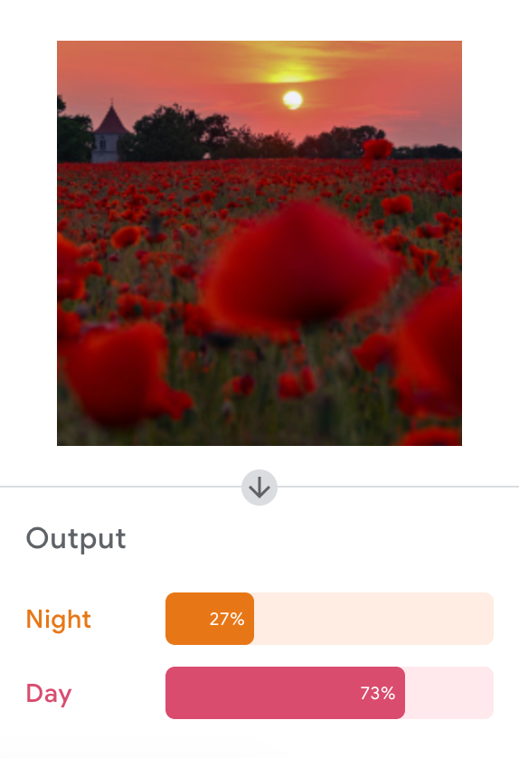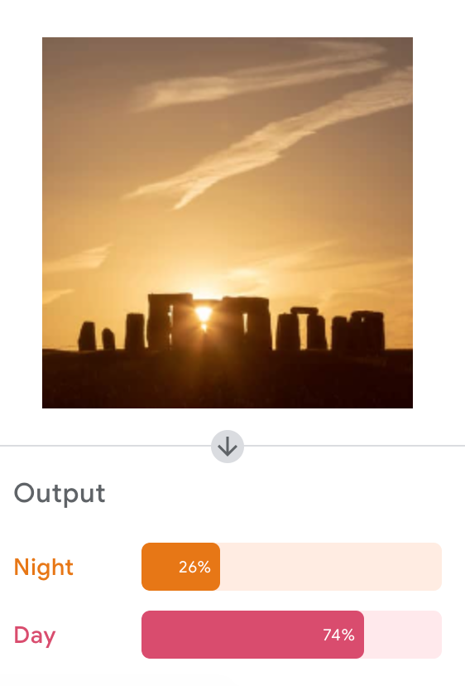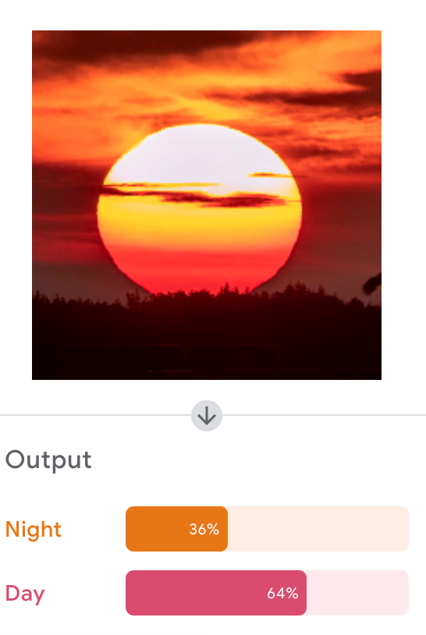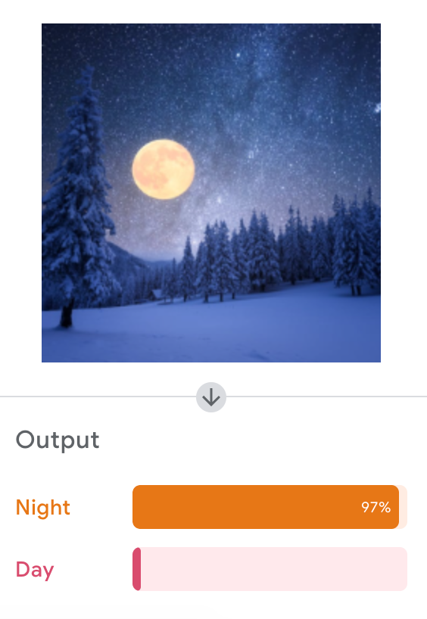

Although the algorithm was not completely certain whether some images were day or night, it was able to correctly guess which was which (all the images I got from searching ‘day’ were labeled as day and the images I got from ‘night’ were correctly labeled). The accuracy seemed similar to a human as when I asked others if the image I showed them was day or night, the results were fairly mixed. However, one result that I did piqued my interest and caused me to go further.

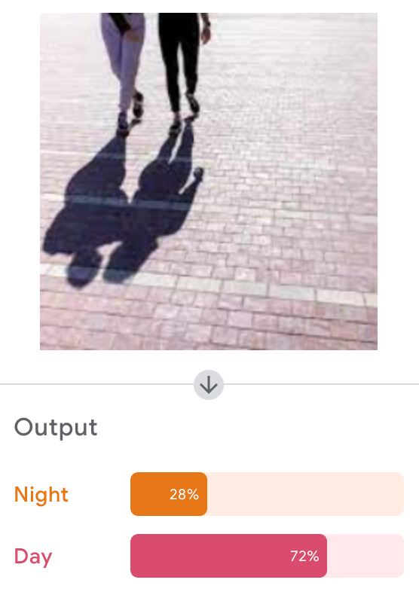

Although the results were overwhelmingly correct, the idea of shadows caused me to delve further as I believed it may be an issue that I did not previously consider when feeding the original images to the algorithm.

When testing images of shadows further, my fears were proven valid.

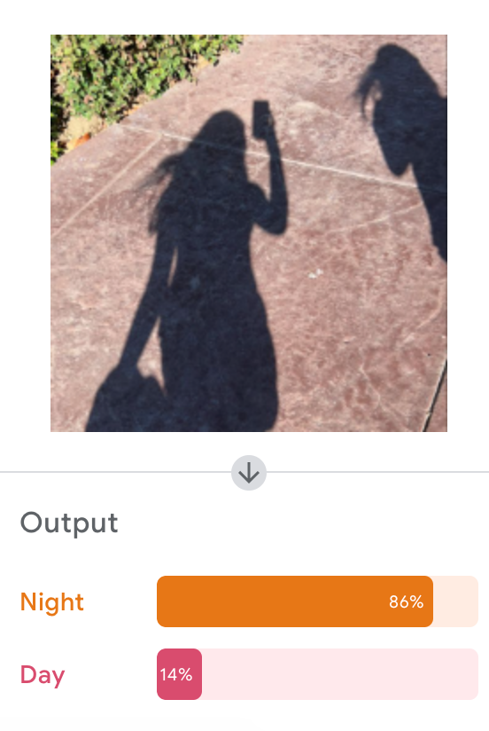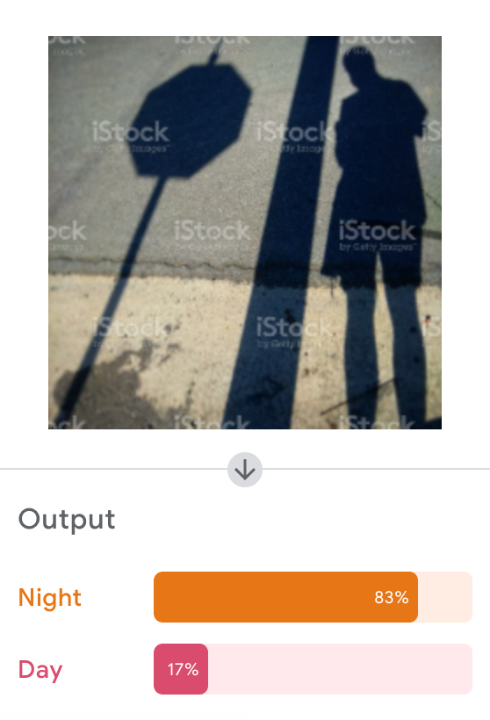

Despite the images clearly being in the day according to the human eye, the algorithm was not able to correctly identify it as such. I believe this is because the algorithm would classify an image as ‘night’ or ‘day’ due to how light or dark it was. This would similarly explain its uncertainty of the sunset images previously as part of it was dark and the majority of it was light.

After discovering this, I went back and added a few more images to both the ‘day’ and ‘night’ categories. All the newly added images contained shadows to keep it consistent between both.

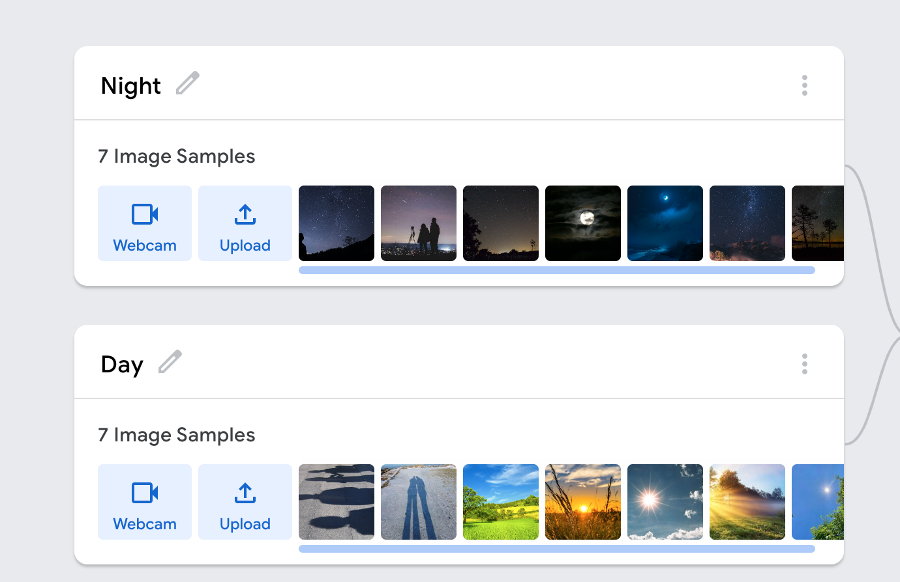

After adding simply two images, the problem with shadows was quickly solved. I then tested the same images as before and got radically different results.

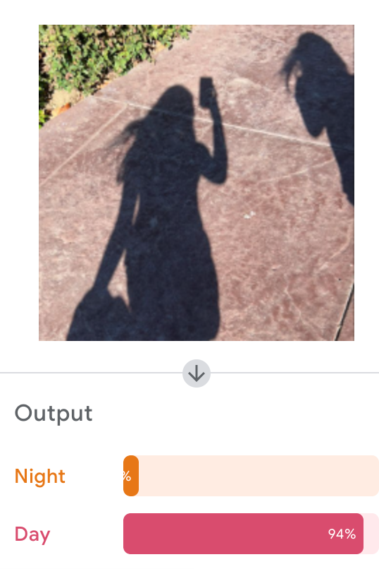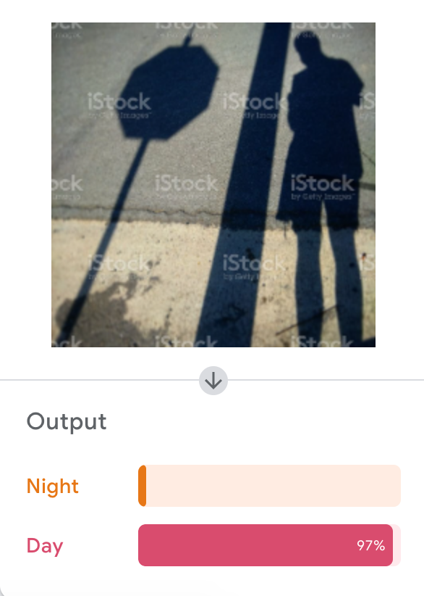

Based on my results, I believe that the methods I chose to complete this task were effective. One change I would possibly make is to make a ‘Sundown / Sunrise’ category in addition to the ‘Day’ and ‘Night’. This would remove the indecisiveness of some of the test images shown previously.

Sharable Link: <https://teachablemachine.withgoogle.com/models/KYYhMOH0p/>